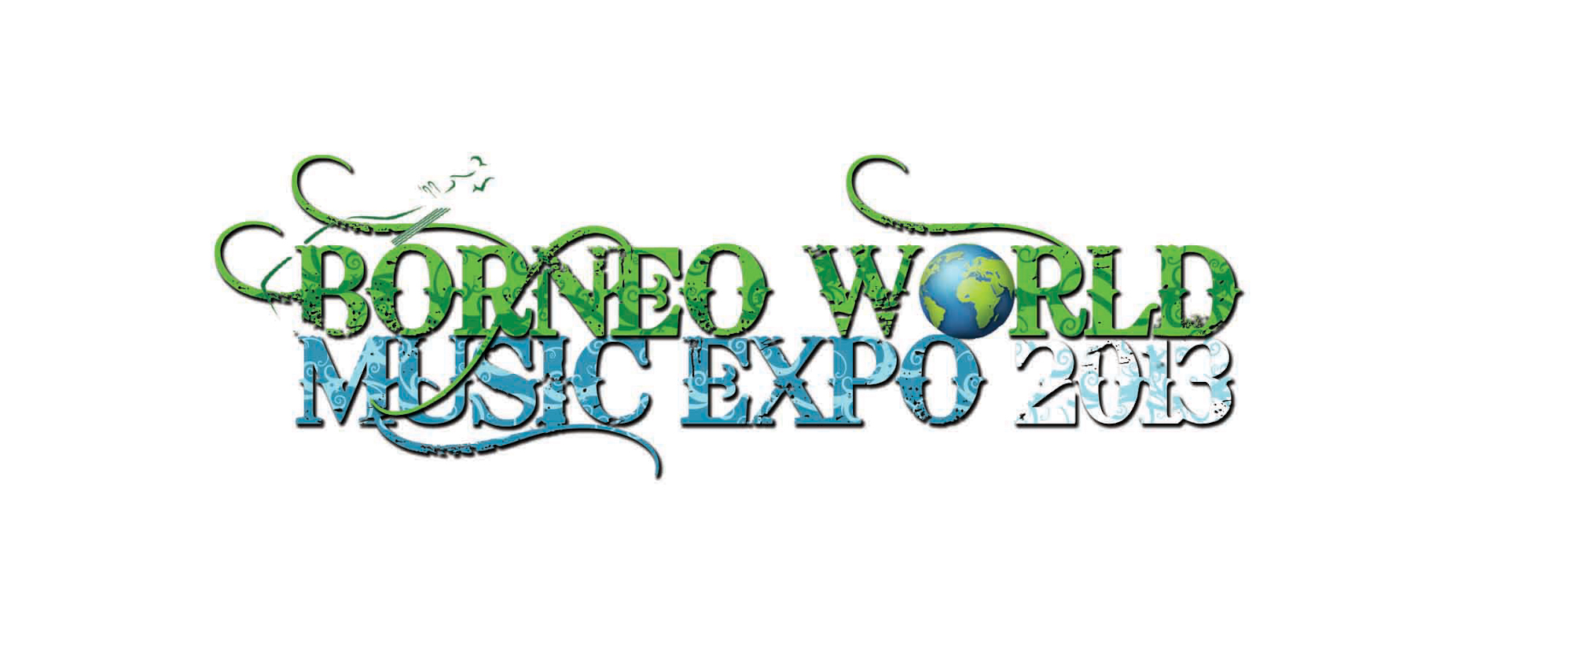
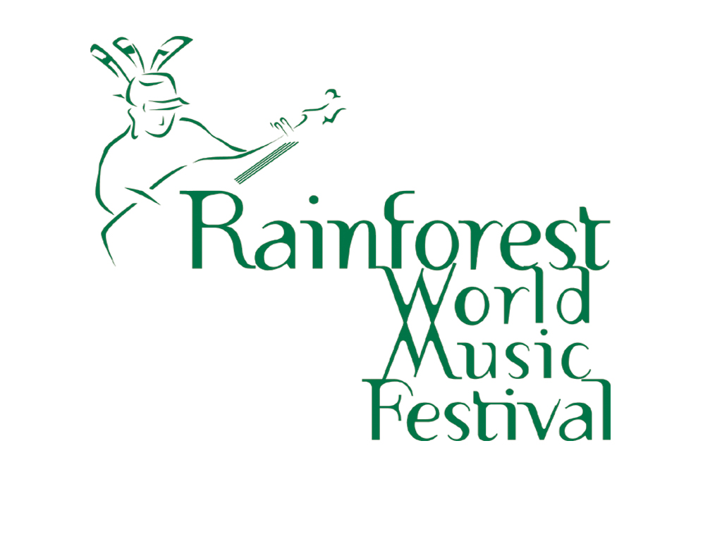
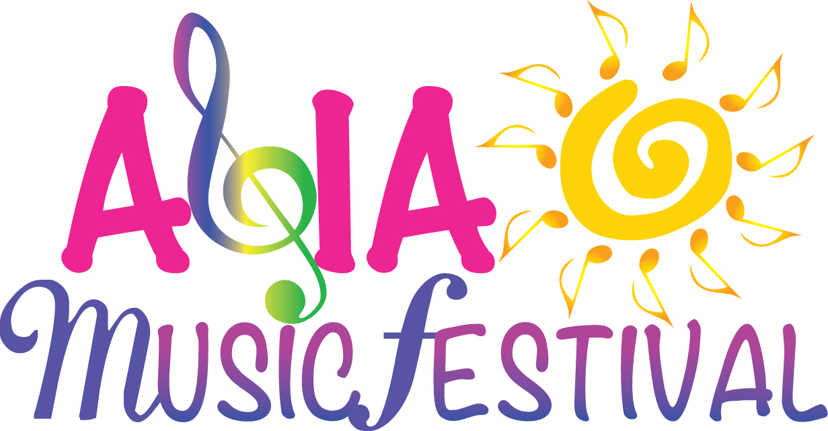
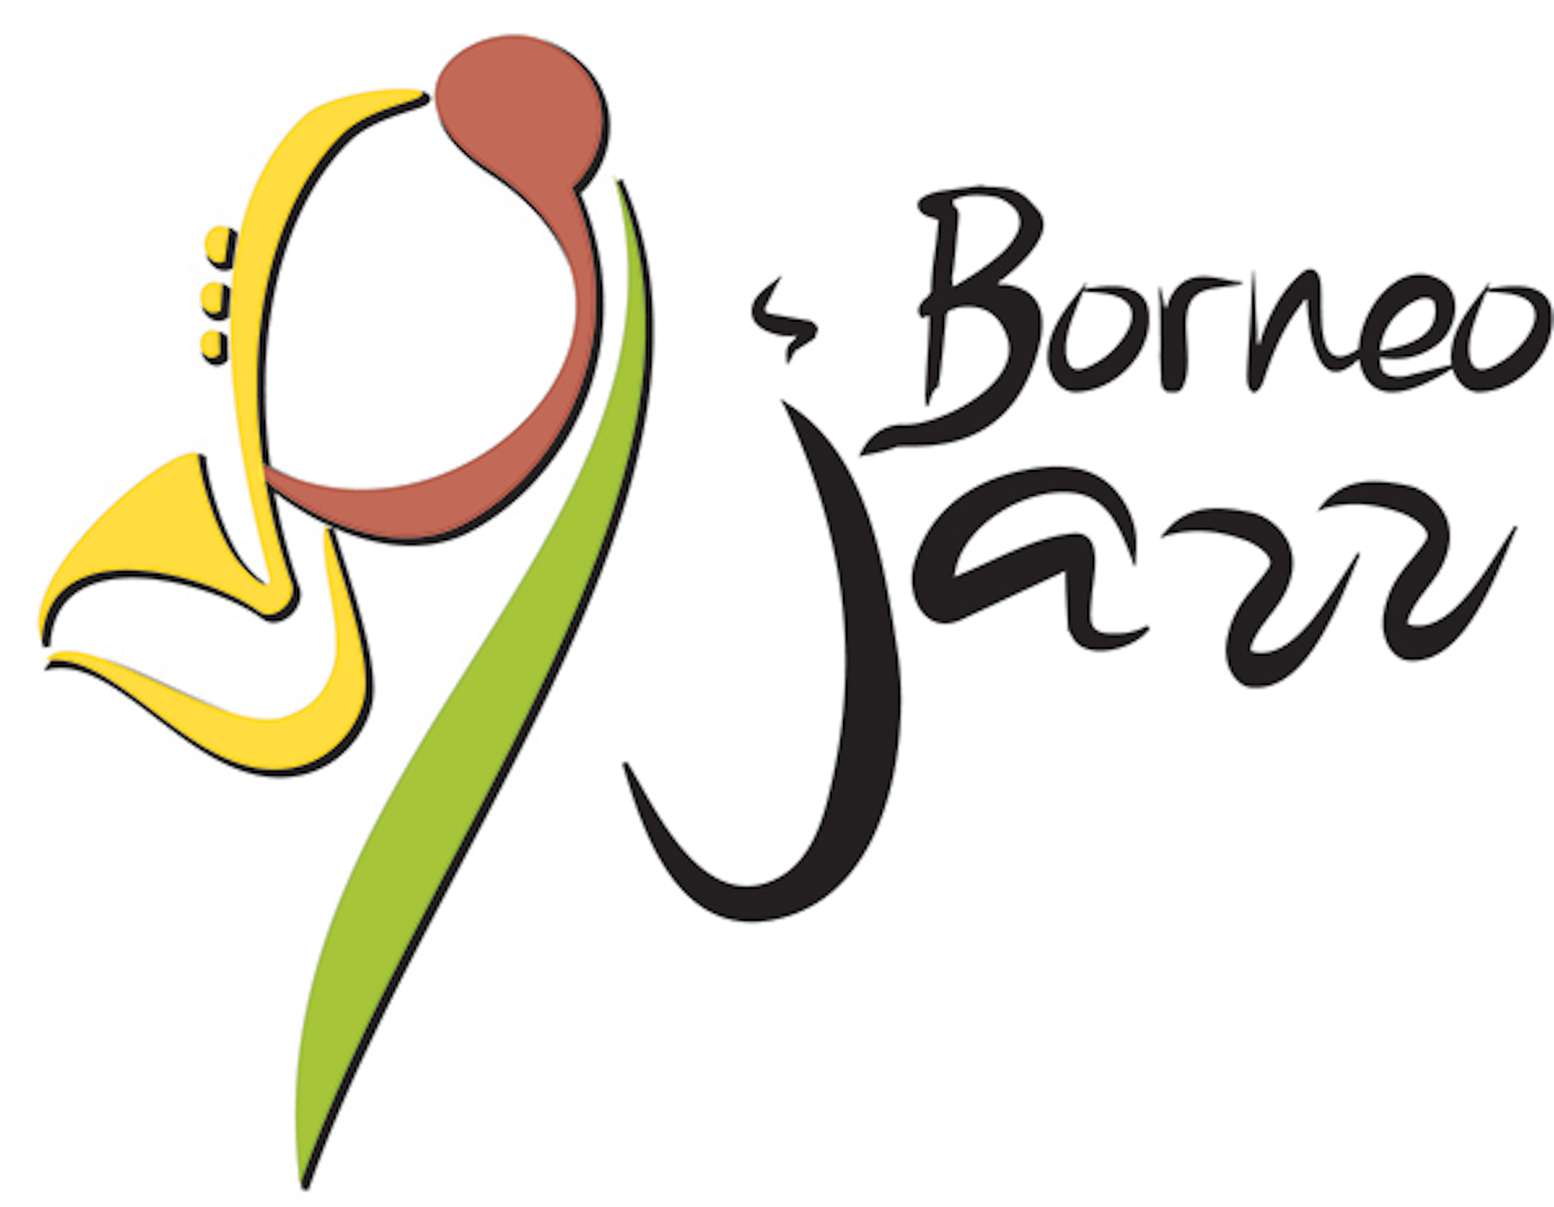

APPLICATION FOR MEDIA ACCREDITATION

- This is only an application and does not guarantee accreditation.
- Pre-publicity, during and post festivals coverage is a privilege for media credentials.
- Media applicants are responsible for their own flights and accommodation arrangement.

1. EVENTS
Media credential request for : | Please Mark ‘X’
- Borneo Jazz Festival : May 9-10, 2014  - Borneo World Music Expo : June 16-19, 2014  - Rainforest World Music Festival : June 20-22, 2014  - Asia Music Festival : October 3-4, 2014 | [ ]  [ ]  [ ]  [ ]

2. DETAIL OF APPLICANTS
Media Outlet / Organisation
Editor / Producer’s Name | Editor / Producer’s Phone or Email
Type of Media
(TV, Online TV, Newspaper, Magazine, Radio, Online Radio, Online News or Blog)
Your First Name | Your Last Name
Designation
(Editor, Publisher, Reporter, Journalist, Travel Writer, Producer, Broadcaster, Photographer, Blogger etc)
Passport Number | Passport Expiry Date
Nationality | Gender (Male/Female)
Office Phone | Mobile Phone
Email | Website
Professional Media ID Card Number | In case of Emergency, Contact (Name/Tel)
Smoking | Others (Vegetarian Food / Etc)
YES / NO
Office Address:

3. PARTICULARS
Circulation / Readership / Listeners Demographic (Monthly or Yearly)
Angle of interest for coverage

Please complete all details and forward to Mr. Gustino Basuan at gustino@sarawaktourism.com

OFFICE USE ONLY

Recommended
Supported
Approved

